Kurt Medley  
Stats Take-home Midterm  
May 2013

Question 1

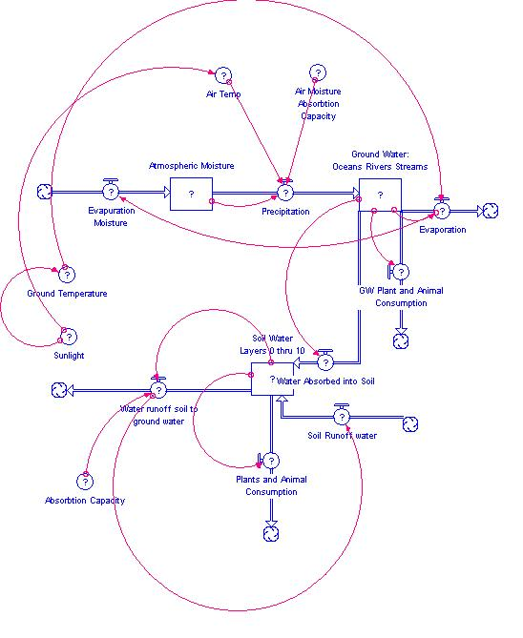

Atmospheric_Moisture(t) = Atmospheric_Moisture(t - dt) + (Evapuration_Moisture - Precipitation) * dt

INIT Atmospheric_Moisture = { Place initial value here... }

INFLOWS:

Evapuration_Moisture = { Place right hand side of equation here... }

OUTFLOWS:

Precipitation = { Place right hand side of equation here... }

Ground_Water:_Oceans_Rivers_Streams(t) = Ground_Water:_Oceans_Rivers_Streams(t - dt) + (Precipitation - Evaporation - Water_Absorbed_into_Soil - GW_Plant_and_Animal_Consumption) * dt

INIT Ground_Water:_Oceans_Rivers_Streams = { Place initial value here... }

INFLOWS:

Precipitation = { Place right hand side of equation here... }

OUTFLOWS:

Evaporation = { Place right hand side of equation here... }

Water_Absorbed_into_Soil = { Place right hand side of equation here... }

GW_Plant_and_Animal_Consumption = { Place right hand side of equation here... }

Soil_Water_Layers_0_thru_10(t) = Soil_Water_Layers_0_thru_10(t - dt) + (Water_Absorbed_into_Soil + Soil_Runoff_water - Plants_and_Animal_Consumption - Water_runoff_soil_to_ground_water) * dt

INIT Soil_Water_Layers_0_thru_10 = { Place initial value here... }

INFLOWS:

Water_Absorbed_into_Soil = { Place right hand side of equation here... }

Soil_Runoff_water = { Place right hand side of equation here... }

OUTFLOWS:

Plants_and_Animal_Consumption = { Place right hand side of equation here... }

Water_runoff_soil_to_ground_water = { Place right hand side of equation here... }

Absorbtion_Capacity = { Place right hand side of equation here... }

Air_Moisture_Absorbtion_Capacity = { Place right hand side of equation here... }

Air_Temp = { Place right hand side of equation here... }

Ground_Temperature = { Place right hand side of equation here... }

Sunlight = { Place right hand side of equation here... }

1 – It is necessary to inquire about the scale of this project. Should this be applied on a regional or global scale? It is important to consider additional stocks and flows of the systems model based on the geologic relevance.

2 – Calculating and accurately reporting the conditions in which these stocks rely is important. The variability between the relationships of stock flow and capacity may generate results bias to the resulting interpretation. How would we calculate these conditions?

3 – What are the most significant flows that affect the stock? There may be unforeseeable flows that dramatically alter the resulting interpretation.

Data Needed:

* Range of plant and wildlife that may affect stock flow
* Initial conditions related to stock initialization
* Equations for converters connected to each of the in/out flows and stocks
* Precipitation levels

Question 2

The variables that I ended up filtering out of the spread sheet included Site_ID, Species_ID, DBH, Live_status and Height. These seem to be relevant data for observing by which species had the greatest height. An important factor to note would be that the bar graph I present below, which is a Mean(height) vs Species_ID graph, gives an average of height for dead and alive trees. I figured their “living” status was unnecessary. However, the species with the greatest average in height changes given this filtration.

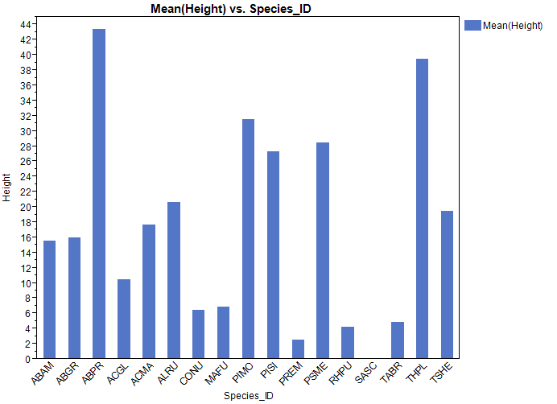 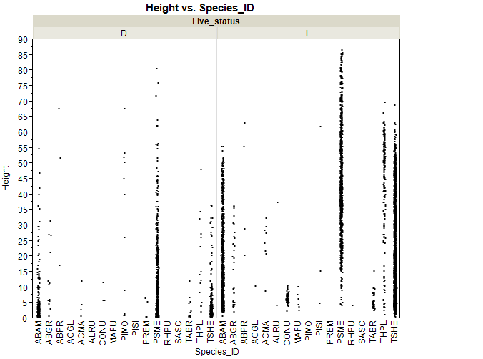

Graph 2 shows the average tree height, categorically separated by dead and alive status (D/L). Here we notice that there tends to be less average height than that of living status. Now I wanted to see which Site_ID had the highest populations of Living and Dead statuses. 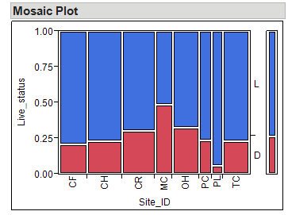 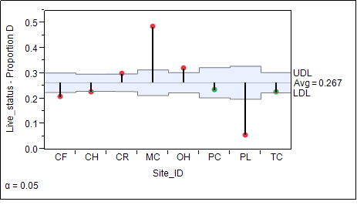

The mosaic plot shows the Site_ID and a count of dead or alive trees. On average we see that the there is a greater percentage of living trees per site than dead trees. Although we can observe that there is a drastically higher percentage of living trees compared to dead trees on site PL. According to the contingency table, there seems to only be 378 trees recorded on site PL whereas site CH has over 1k instances of D or L trees.

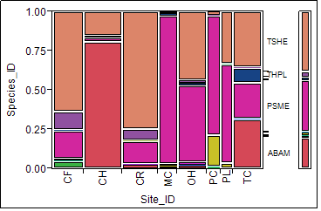

Here the filtration is set for examining which species of trees populated which site ids. The mosaic shows that the majority of the PL site id is populated with PSME. CH is mostly populated with ABAM trees. It might be logical to examine the evolutionary traits of PSME trees in the sites with heavy populations to theorize why those sites support that particular tree. Also it may be worth examining why site CH has the most dead ABAM trees.

Question 3

1.

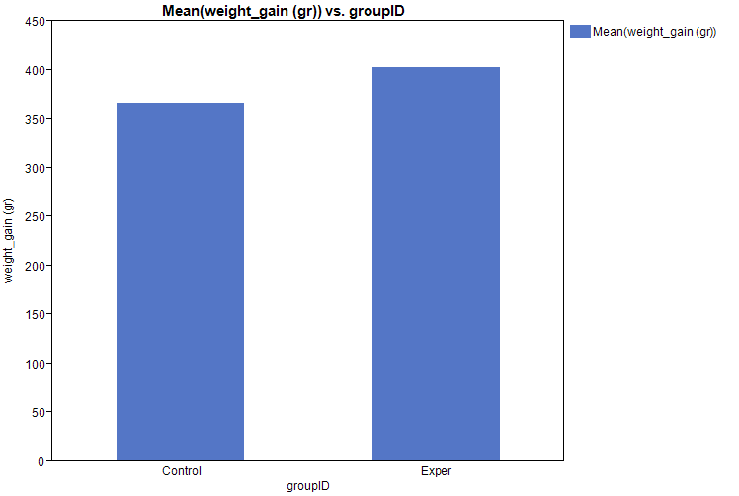

The data are within approximate range and a t-test is suitable given the sample size. There are no significantly unreachable subjects outside of the range of 275 grams and 475 grams.

1. H0: Subjects fed high-lysine corn do not gain weight faster than chicks fed normal corn.

Ha: There is a higher weight gain associated with chicks that eat high-lysine corn than there is with chicks that eat regular corn.

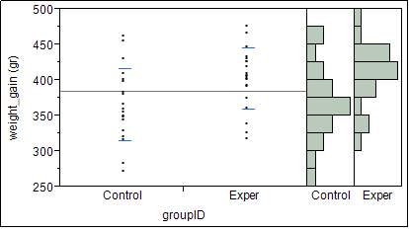

Given the plot we can assert that the experimental subjects (chicks fed corn with high-lysine) have higher weight gains than the ones fed regular corn. We can see that the average for those in the experimental group have more chicks above the 375 gram marker than the control group.

1. (optional) give a 95% confidence interval for the mean extra weight gain in chicks fed high-lysine corn.

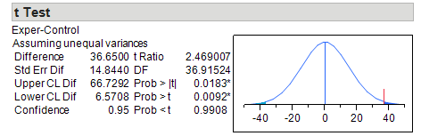

Question 4

1. Make a table of means and standard deviations for the four colors and present the data graphically.

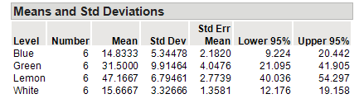

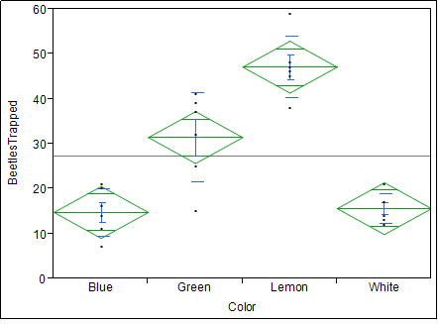

1. State the null and alternative hypotheses for an ANOVA on these data, and explain in words what the ANOVA will test in this setting.

H0: The colors of the board have no effect on the number of beetles trapped in the field of oats.

Ha: Specific board colors have an effect on the number of beetles trapped in the field of oats.

The one-way ANOVA will give a summary of fit test in which it will calculate the coefficient of determination. It will provide a measure of how well an observed outcome will be replicated by the model. Analysis of variance gives a statistical test of the means of several groups and determines whether or not they are equal. It generalizes the t-test of more than one group (aka Blue, Green, Lemon, White).

1. Run the ANOVA (in JMP or resampling) and report your results.

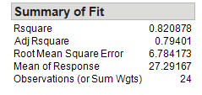 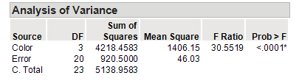

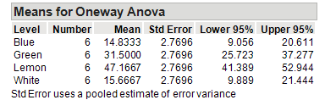

We notice that there isn’t a significant difference between beetles trapped by colors Blue and White. They represent the most ineffective colors for trapping beetles. Green boards attract more beetles than Blue and White, and Lemon boards represent the best colors for attracting beetles. Evaluating the means shows us the difference in beetles trapped between colors. Our Rsquared (or coefficient of determination) value shows an (approx.) 80% accuracy of observed outcomes presented by the model.